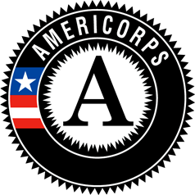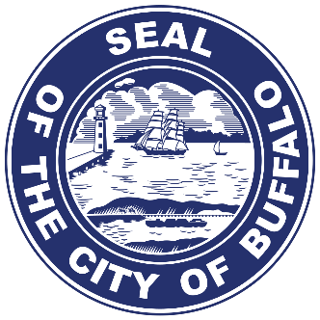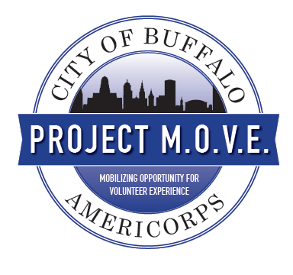

**Project M.O.V.E. Buffalo**

***Mobilizing Opportunities for Volunteer Experience***

This document includes some highlights of our program thus far, through two years of fruition, kindly see the narrative and images that show some of the exciting initiatives our Project M.O.V.E. AmeriCorps VISTA members have engaged in and contributed to. Due to space constraints we have chosen the following four initiatives below, to support our application for Best new AmeriCorps VISTA Program Award.

1. National Service Recognition Day (Page 2)
2. AmeriCorps Week (Page 7)
3. Addressing the Opioid Epidemic (Page 11)
4. Beautification and Restoration of Neighborhoods (Page 14)

**Juweria Dahir**

External Affairs Manager

AmeriCorps VISTA, Project M.O.V.E., Program Director

P: (716)-851-5534 F: (716)-851-5306

E: JDahir@city-buffalo.com

# 1. Recognizing Service Members

## National Service Recognition Day

**Welcome**

* Oswaldo Mestre, Jr., City of Buffalo Chief Service Officer, was the MC for the event.
* He spoke briefly about how service has shaped his life and how service can impact our city

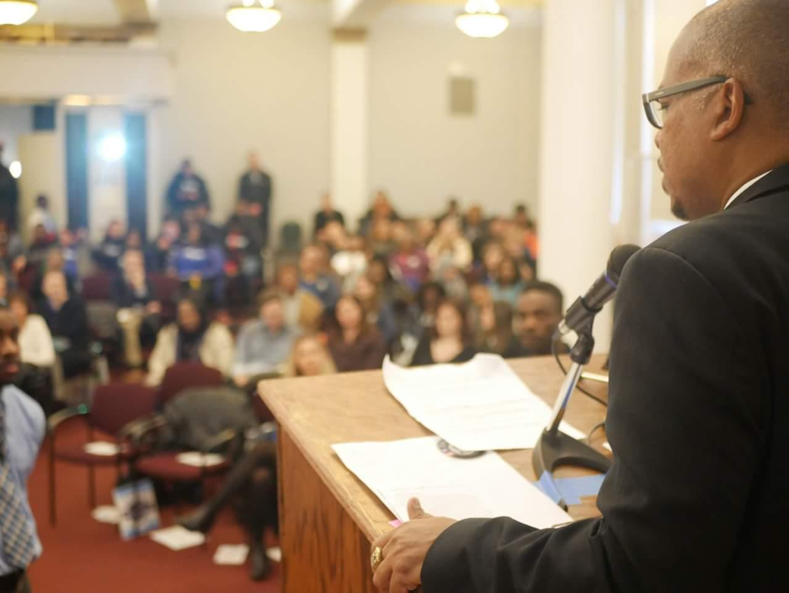

**Reflection**

* Pastor Kenneth Simmons reflected on how his term of service as an AmeriCorps member helped get him to where he is today

**Greetings**

* Kim Luangpakdy, Buffalo History Museum Director of Development, expressed her excitement that the History Museum was hosting this event.
* She also spoke about her time as an AmeriCorps member and why service is important to her

**Recognition of the Occasion**

* Mayor Byron W. Brown came up on stage to thank all of the organizations and volunteers dedicated to national service in the City of Buffalo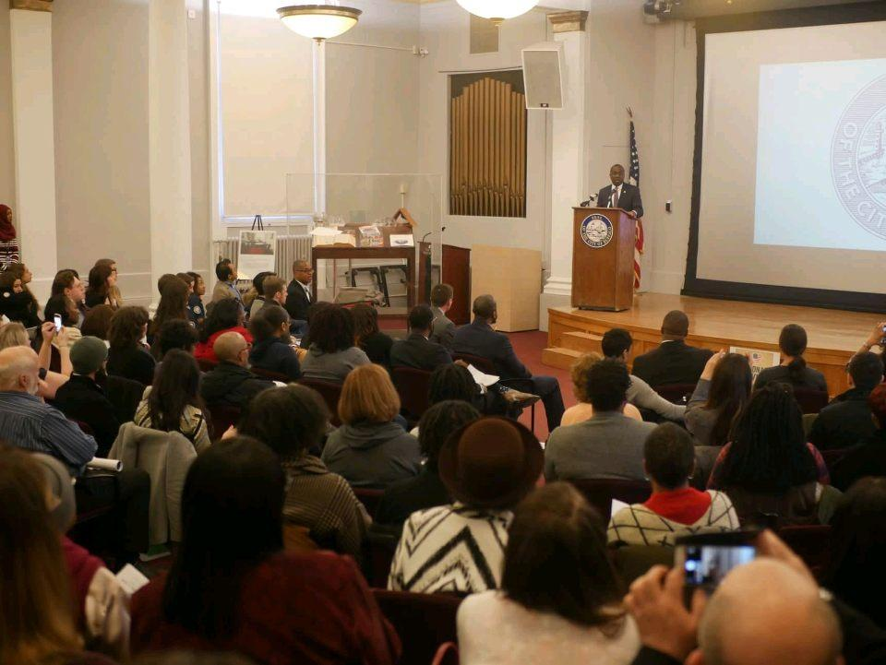
* Timothy Hogues, Erie County Senior Services Commissioner, was representing Mark Poloncarz, Erie County Executive and shared the Mayor’s gratitude to all those who serve in our community

**Remarks**

* Jessica Vasquez, Corporation for National and Community Service State Program Director for New York, shared CSO Mestre’s belief that Buffalo is a special city and that the city does a tremendous job with national service

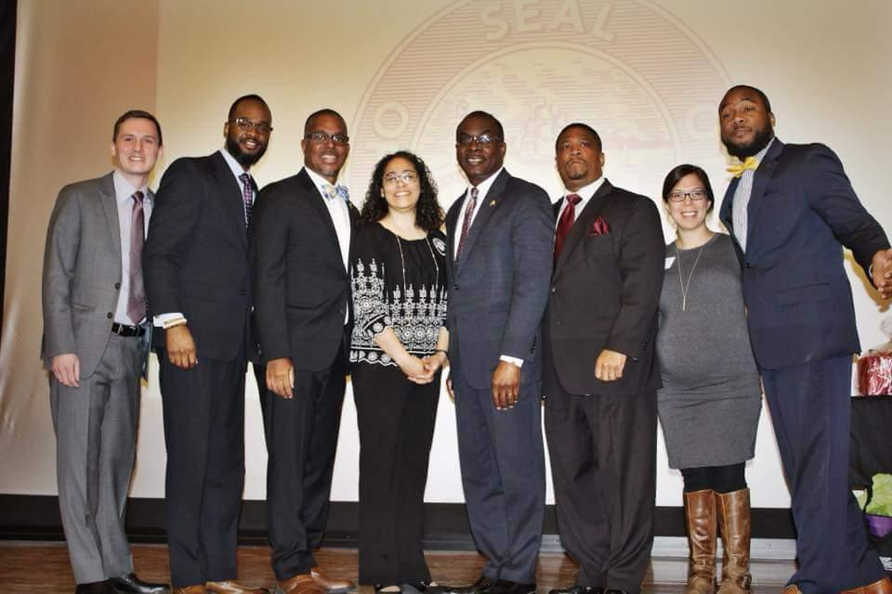

**Award Presentation**

* 9 award plaques were given out by the Program Directors of the participating service organizations: Dianne Wingo (Read to Succeed), Maria Lopez (Senior Companion Program), Elizabeth Mercer (The Service Collaborative), Tyler Flemming (The Service Collaborative – ABLE), Codi Blumenstein (The Service Collaborative – YouthBuild), Marco Notaro (The Service Collaborative), Dionte Heath (Cradle Beach – Project S.O.A.R.), Mary Hardy (Foster Grandparent Program), and James Kpainay (City Hall, Division of Citizen Services - Project M.O.V.E.)

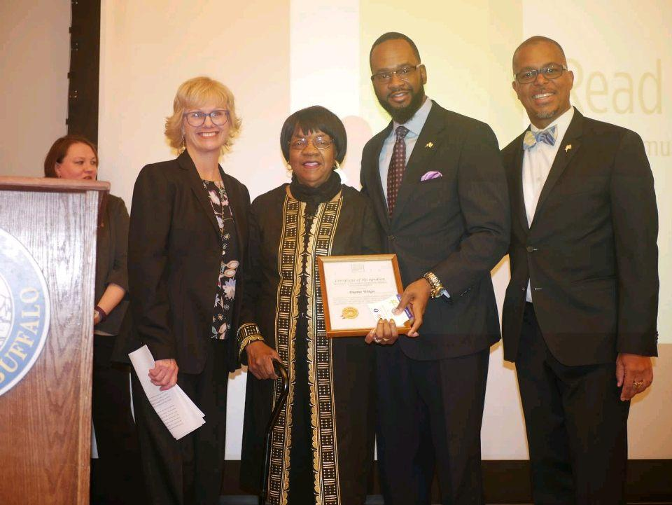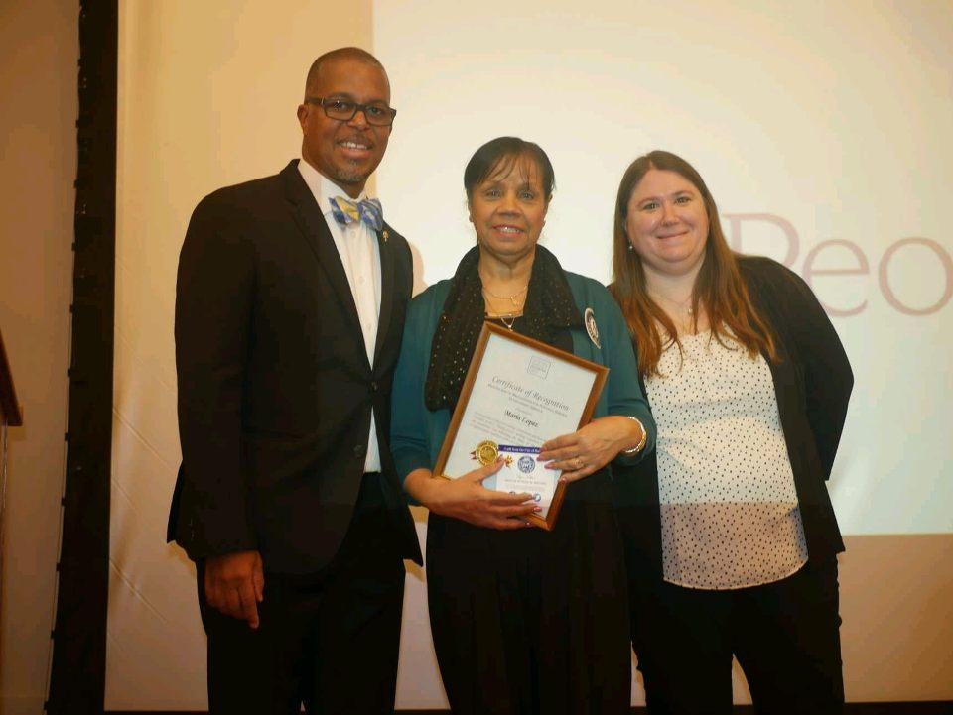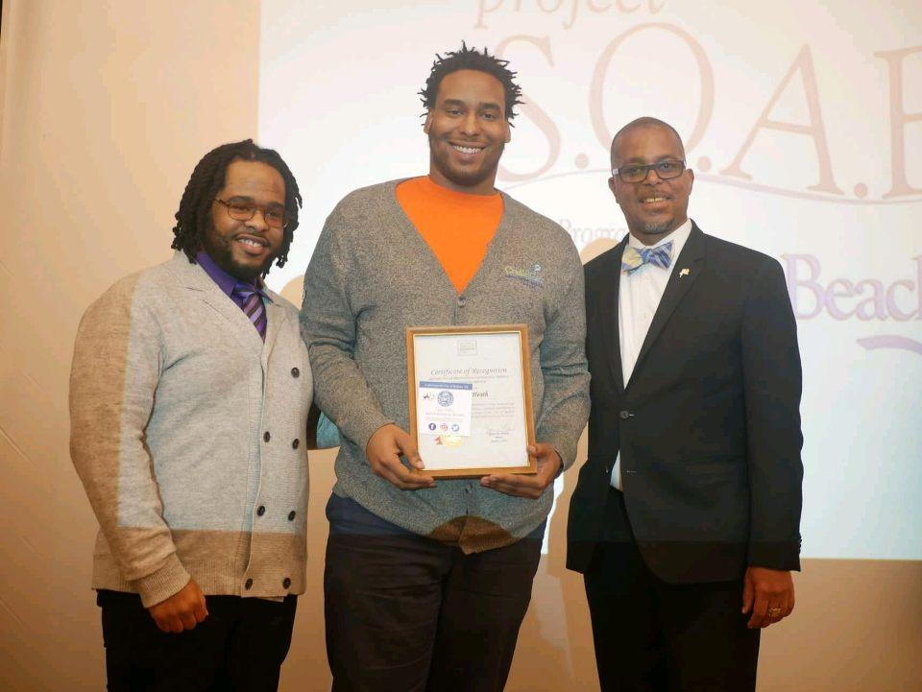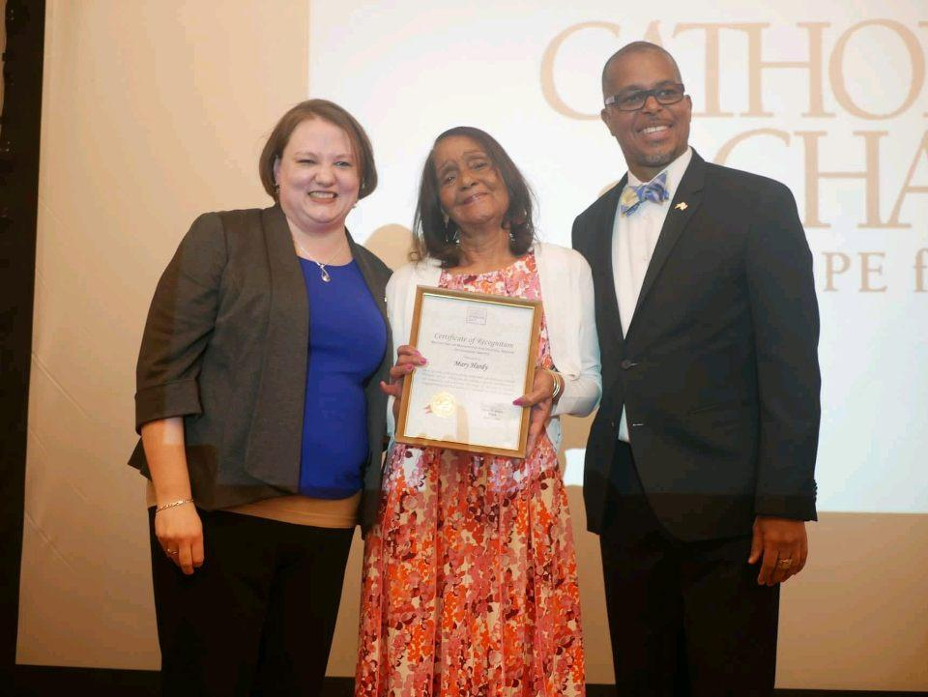

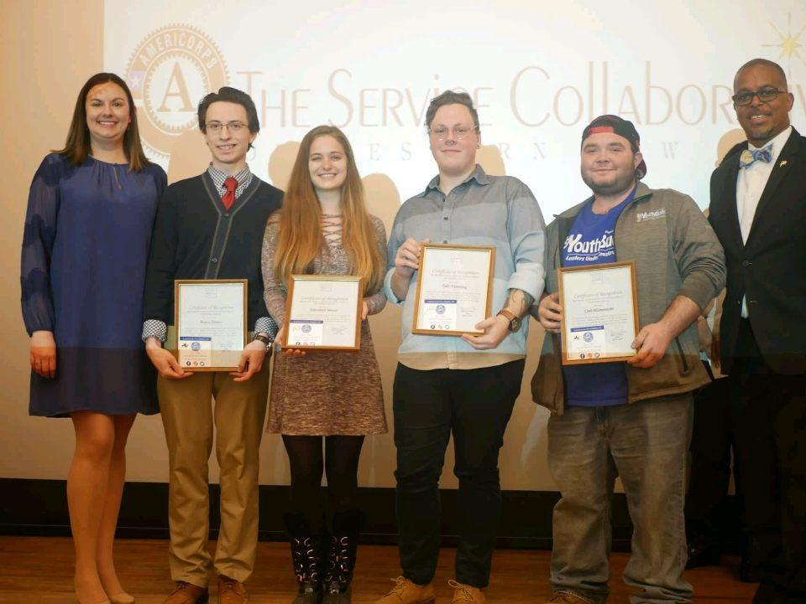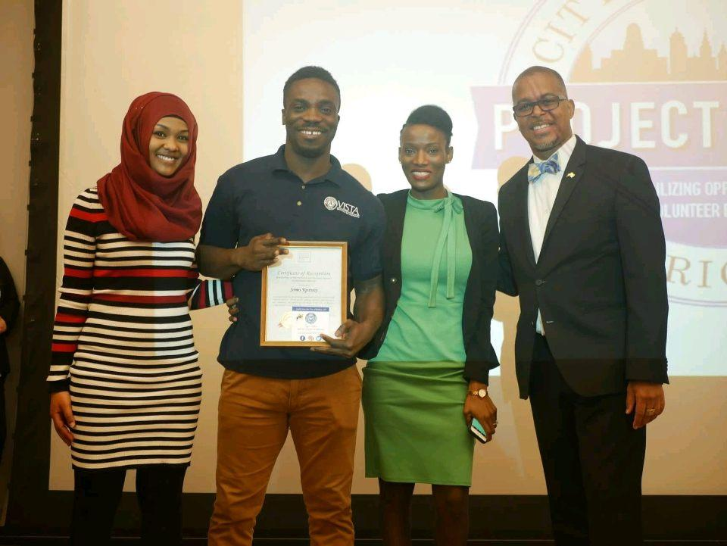

* 1 special plaque was given to Joanne Gadra in memory of her late husband, Gerald, who dedicated his life to service, specifically with RSVP

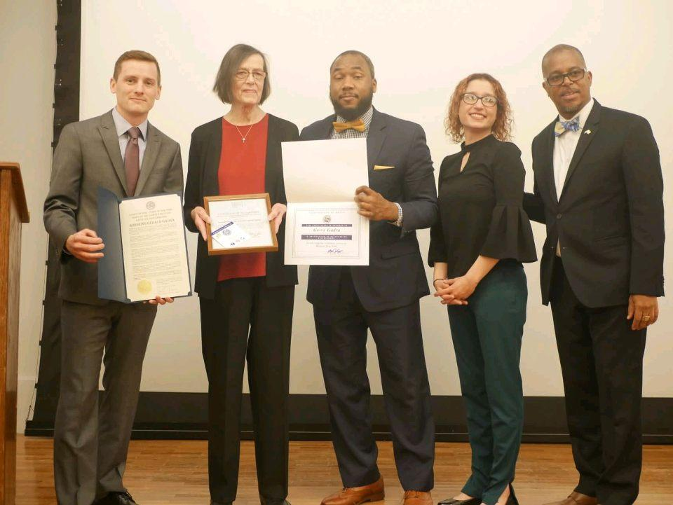

**Roll Call**

* Timothy Hogues, Erie County Senior Services Commissioner, lead the roll call where he called out each service organizations name. YouthBuild, a part of The Service Collaborative of WNY, brought the most enthusiasm and took home the Spirit Stick this year.

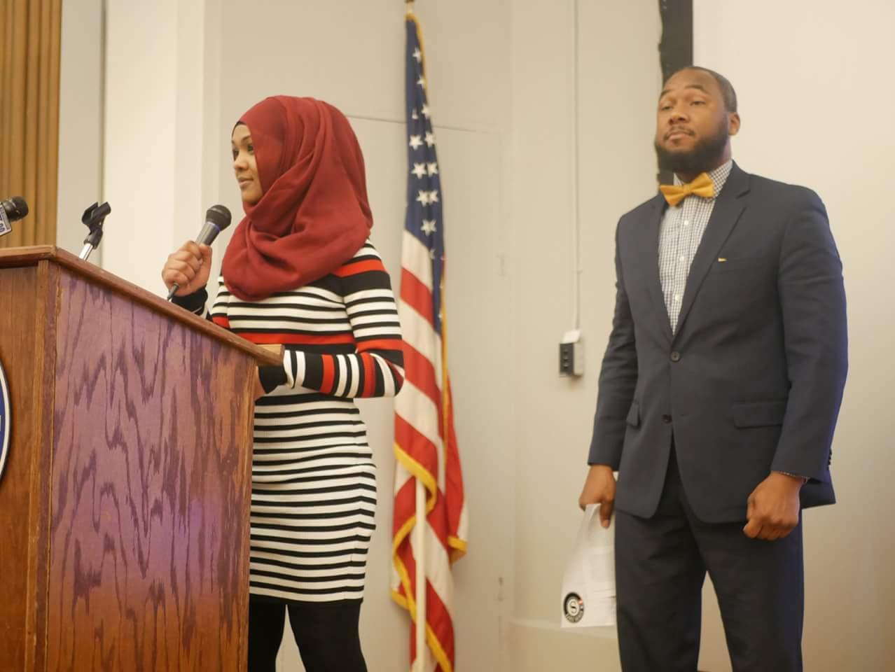

**Special Presentation & Raffle**

* A raffle was held where 11 participants from the crowd received gift baskets

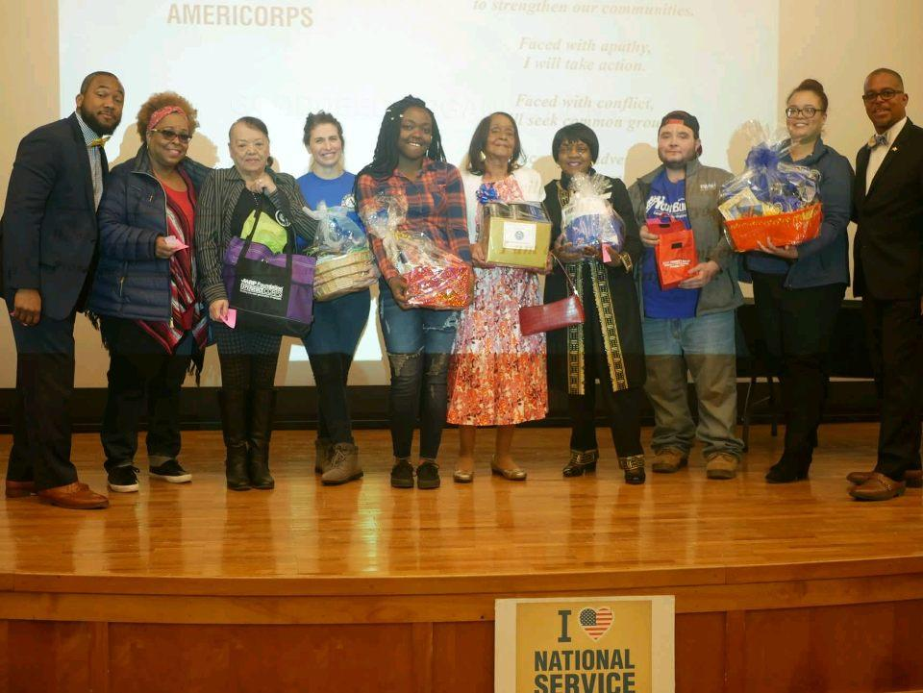

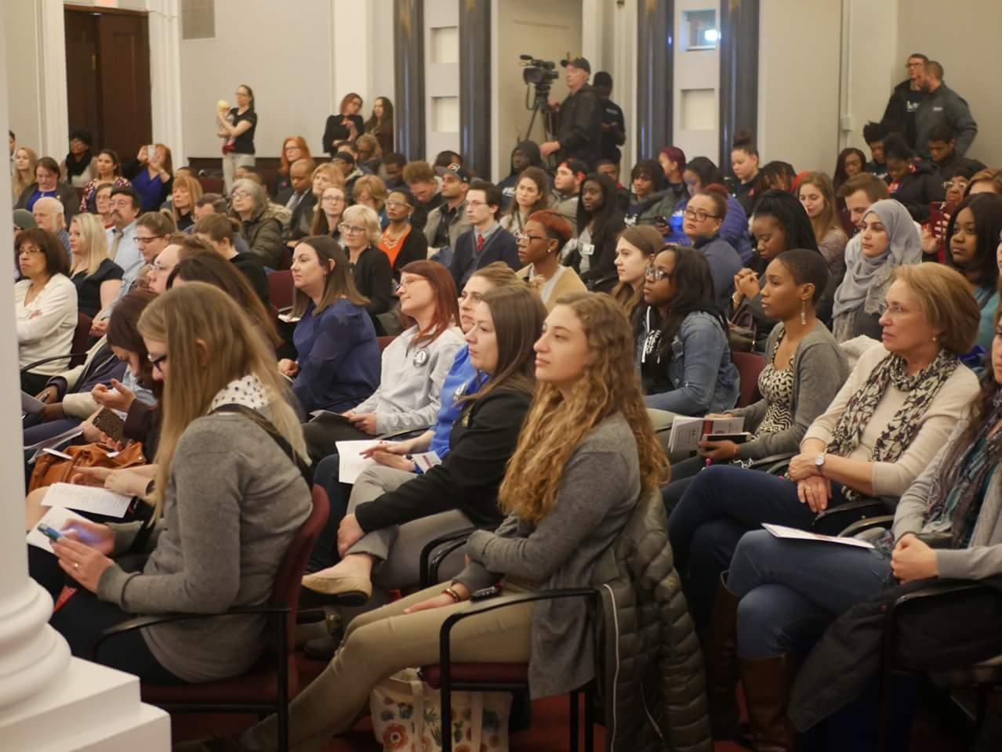

**Pledge to National Service**

* CSO Mestre lead the entire crowd in a pledge to national service

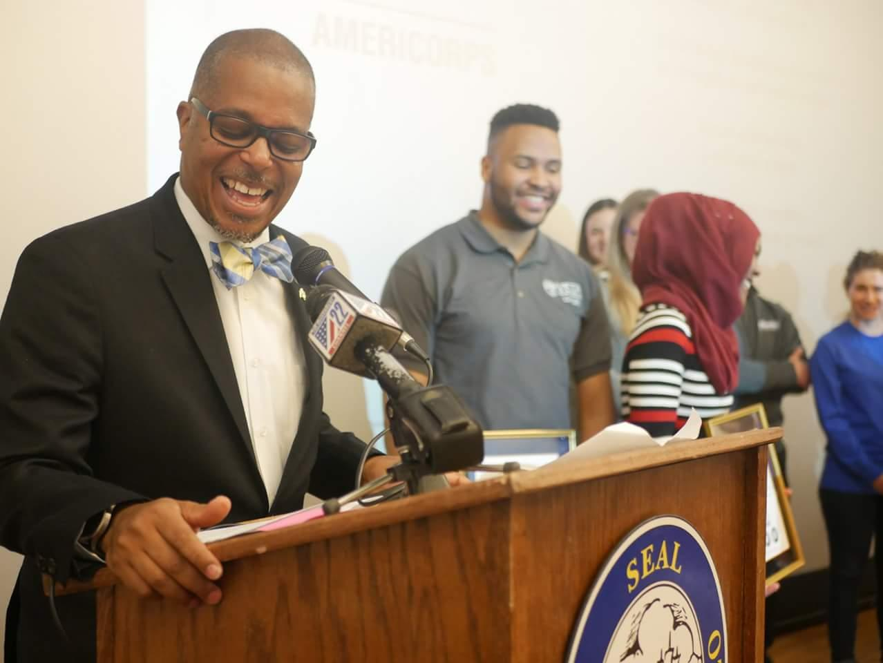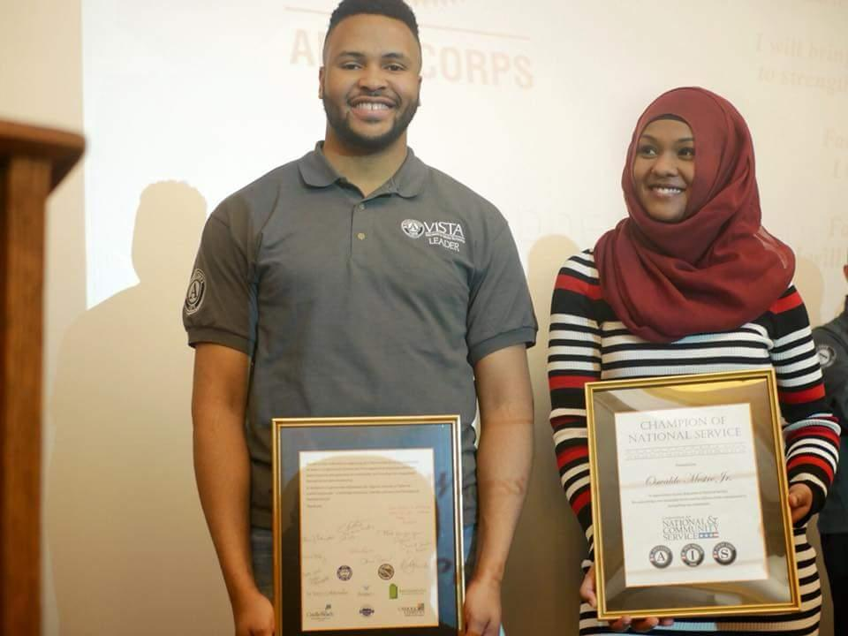

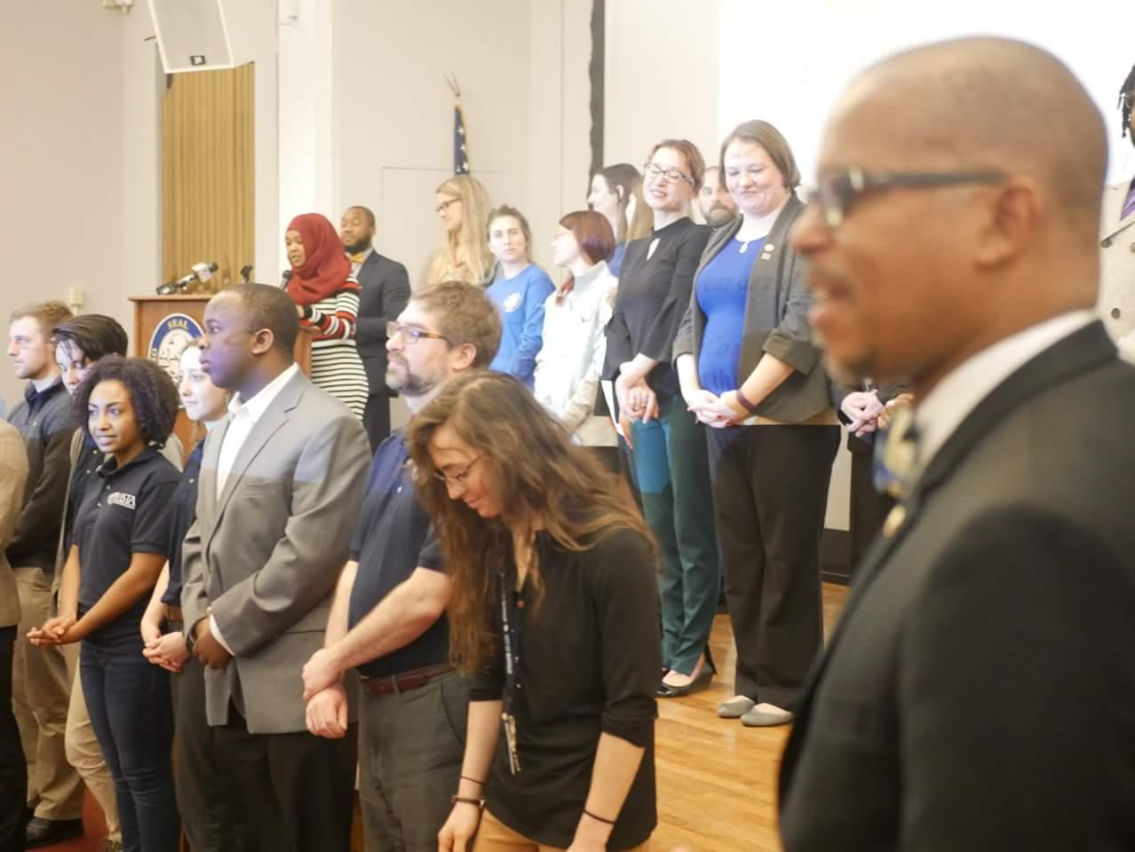

# 2. The AmeriCorps Experience

## AmeriCorps Week

**Mayor Byron W.Brown issued a proclamation on Thursday, March 15, recognizing this week as 2018 AmeriCorps Week.**

This entire week, the city of Buffalo, in New York, is celebrating all things AmeriCorps. Project M.O.V.E. Buffalo, the AmeriCorps program in Buffalo City Hall, hosted their very first VISTA Member Exchange Program. Members of Project M.O.V.E. had the unique opportunity to meet with VISTA members assigned to various service locations across the city who shares a similar mission and focus with [Project M.O.V.E.. The following day, Project M.O.V.E. members hosted their participants. The Service Recruitment Fair was held in City Hall and featured sponsoring organizations and service locations with AmeriCorps programs in Buffalo. A fundamental part of this week, project M.O.V.E. Buffalo served as a meeting place for the diverse groups of AmeriCorps and Senior Corps programs in WNY to share information, formulate a committee that meets on a quarterly basis in order to provide an opportunity for cross-collaboratory thinking and increasing awareness of the amazing AmeriCorps and SeniorCorps programs in WNY. Project M.O.V.E. will conclude the week-long festivities with a pot-luck with invited guests, including alumnus from the inaugural cohort of vistas.

**Day 1 VISTA exchange Program**



VISTA members went to several AmeriCorps sites and in exchange VISTA members from project M.O.V.E. Buffalo also hosted AmeriCorps at City Hall

**Day 2 Show and Tell**



As project M.O.V.E Buffalo evolves, we would like to spotlight our AmeriCorps VISTA members work here in the City of Buffalo. Although the Mayors Office is their primary site, some of them serve from their secondary sites too. Below is a short synopsis of their placement sites and responsibilities

* De’yron Tabb,  is the Buffalo Employment Training Center V.I.S.T.A: he building on internal capacities to eradicate poverty through employment advocacy work and community outreach pertaining to employment opportunities.
* Megan Fisher, is the Buffalo Urban Renewal Agency V.I.S.T.A: She is creating a database of affordable housing units in Buffalo for citizens and government use, in addition to that she analyzes survey data from Annual Action Plan meetings, and conducting grant research.
* Dana Glantz, is the Open Data Buffalo V.I.S.T.A: She is using open data to  improve the quality of the program, and encourage residents to use the platform to be more informed about the activities, opportunities and challenges in their neighborhoods.
* Tirsit Valentine, is the Police Athletic League V.I.S.T.A: She is developing programs to strengthen PAL’s fundraising and promotional efforts in order to reach the vulnerable population in Buffalo.
* Josh Stromberg is the Wellness Institute V.I.S.T.A: He is working with the Wellness Institute providing health promotion activities and is seeking to advocate on how the built environment, city planning, and regular physical activity can improve the quality of life for the communities he is serving.
* Michael Allen, is the Love Your Block V.I.S.T.A: He is focusing on the impoverished of the City of Buffalo and assisting in creating better neighborhoods throughout Buffalo’s citizen participation Academy - a blueprint for citizen engagement
* Emily Avondolio, is the Environmental Love Your Block V.I.S.T.A: She is working on creating sustainable solutions to some of the civic issues plaguing the city.
* Ryan Schupps, is the Love Your Block V.I.S.T.A: His work focuses on the impoverished of the City of Buffalo and assisting in creating better neighborhoods throughout Buffalo. In addition to that he formulates the Mayors Bloomberg Grant opportunities, as we continue to solve the city’s most pressing issues
* James Kpainay, is the Save Our Streets V.I.S.T.A: His work focuses on dilapidated neighborhoods and collaborating with our private and public partners to eradicate poverty through beautification and restoration efforts. In addition to that James is working on making data pertaining to neighborhood beautification and restoration accessible for the general public so that they may join the effort of restoring their neighborhoods.
* Malik Stubbs, is the My Brothers Keeper V.I.S.T.A: He focuses on creating support programs to empower young men of color, provide them the right tools to help them plan for a better future.
* Langh Thang, is the Buffalo State College V.I.S.T.A: His role focuses on developing  educational programs for the vulnerable population in Buffalo, in particular the new American and the youth of our communities..

**Day 3 Member Appreciation Day - Highlighting Antonio Regulier, VISTA Leader**

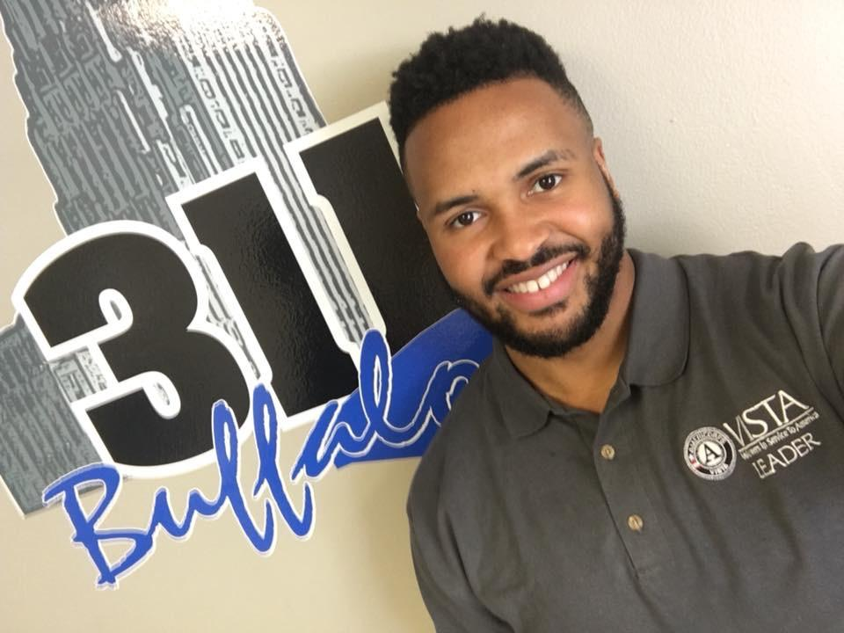

Service has always been an important part of Antonio Reguliers life. After serving his first VISTA term in City Government, Antonio knew that he wanted to continue working in the public sector, but also really loved the national service aspect of what he had been doing. When he was offered the position with Mayor Byron W. Brown Project MOVE Buffalo VISTA Leader - he knew it was a perfect fit! Antonio plays a key role in creating and shaping what the AmeriCorps VISTA program looks like in the City of Buffalo. When he is not serving, Antonio is pursuing a Masters Degree in Public Administration, where he is undertaking extensive study in public policy. In addition to taking full advantage of the varied perspectives of his role, Antonio hopes to effectively engage stakeholders and residents at all levels to eradicate poverty.

**Day 4 Roundtable, Service Fair & Proclamation**

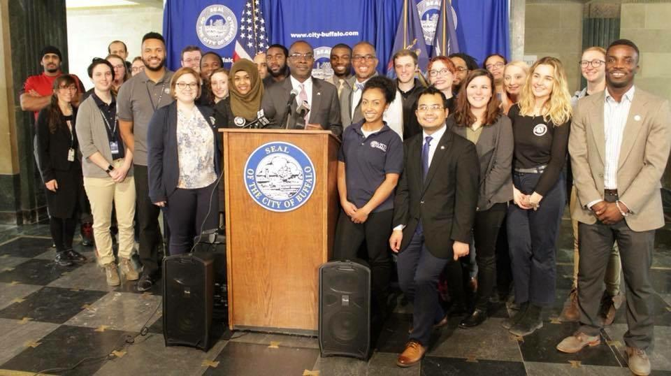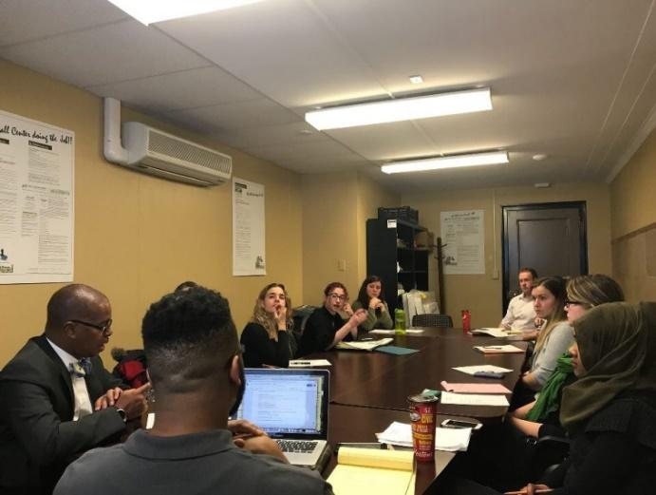

A roundtable has been established from the on-going efforts of collaborating with the many service sponsor sites in WNY; whereby all the different AmeriCorps and Senior Corps programs in WNY were invited to participate in a discussion on service and what that looks like for the region. This unique opportunity, hosted by the City of Buffalo Chief Service Officer Oswaldo Mestre and Project MOVE Buffalo Program Manager Juweria Dahir stems from the existing effort of creating a structured forum for attendees to meet and learn about each other's roles, affiliations, programs, success stories and expertise.  With this goal in mind, the roundtable hopes to serve as a platform for national service and discuss ways in which we can all cross-pollinate ideas and resources. Below is a nutshell of our discussion:

* How do we increase awareness and education about service?
* Considering the political climate, promoting service is highly important. We want to ensure that national service is an item on the Mayor’s agenda for continued advocacy.
* Highlighting service projects that are ongoing in the City of Buffalo that service members can partake in.
* Sharing information about volunteer opportunities that may be or may not be national service.
* This initiative extends beyond Western, NY.
* The strategy is to incorporate service in their (residents, students, senior citizens, out-of-school youth, etc) life plan and as an alternative option if the traditional route does not work)

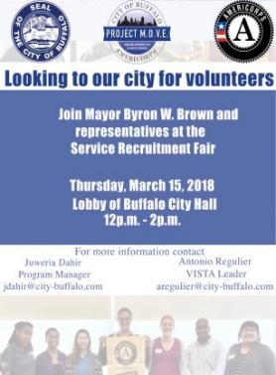



Following the round table discussion, a service fair was held in Buffalo City Hall’s Lobby. All city employees, students, seniors and the general public were invited to learn more about the national service opportunities in WNY. The fair brought together current AmeriCorps, SeniorCorps and Alumni’s to talk one-on-one with about their experiences and how their work has impacted the region. The fair ended with the Mayor issuing a proclamation.

**Day 5 Serving Putlock styles**

To wrap up the long festivity week, members and supervisors from Project MOVE Buffalo were invited to a Putlock in City Hall, to show gratitude to all our amazing national service members.

# 3. Addressing the Opioid Epidemic

## Narcan Training

**Introduction**

* The Erie County Department of Health began the session by talking about the opioid epidemic in the United States and specifically in Erie County. This involved diving into many statistics that showed just how severe the epidemic is

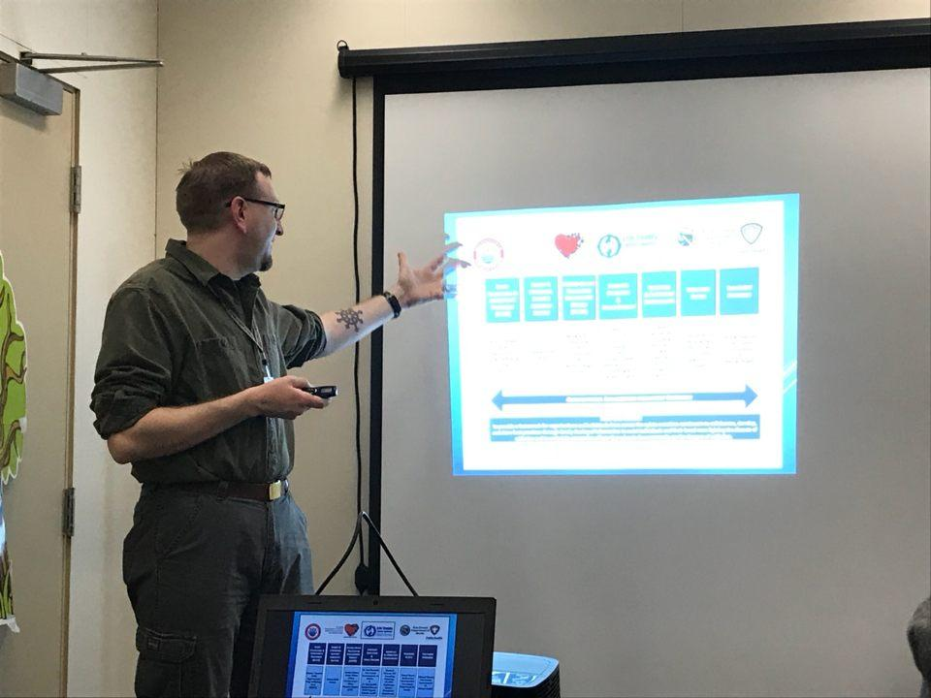

**Opioids History and Facts**

* The presenters discussed the history of opiates, related legislation, and how we got to the situation we’re in today
* Next we learned about the various types of common opioids ranging from heroin to fentanyl, and how lethal they can be

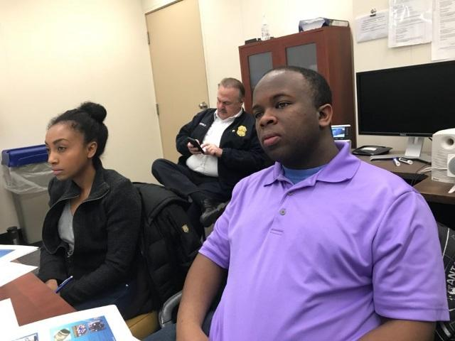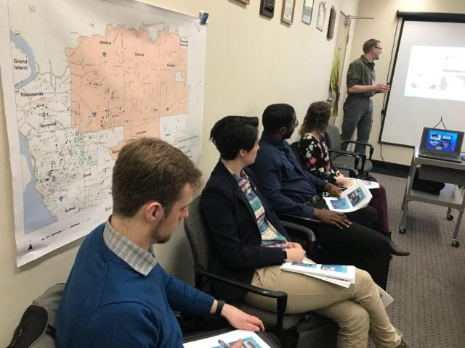

**What to Do in the Case of an Opioid Overdose**

* We first went over how to identify an opioid overdose by recognizing its signs and symptoms
* We then learned about how Narcan (Naloxone) works to reverse an opioid overdose
* Finally we were taught how to use the Narcan nasal spray on a person we suspect has overdosed on opioids
* We were all given 2 doses of Narcan and a certificate of completion

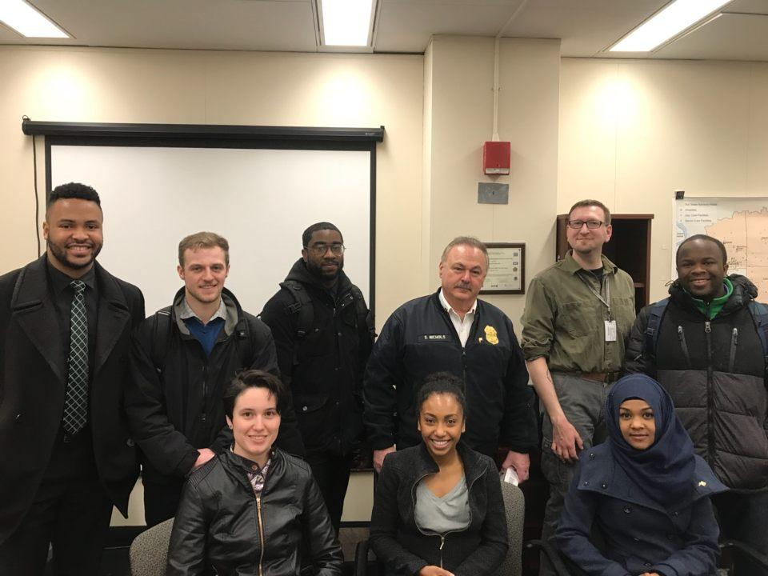

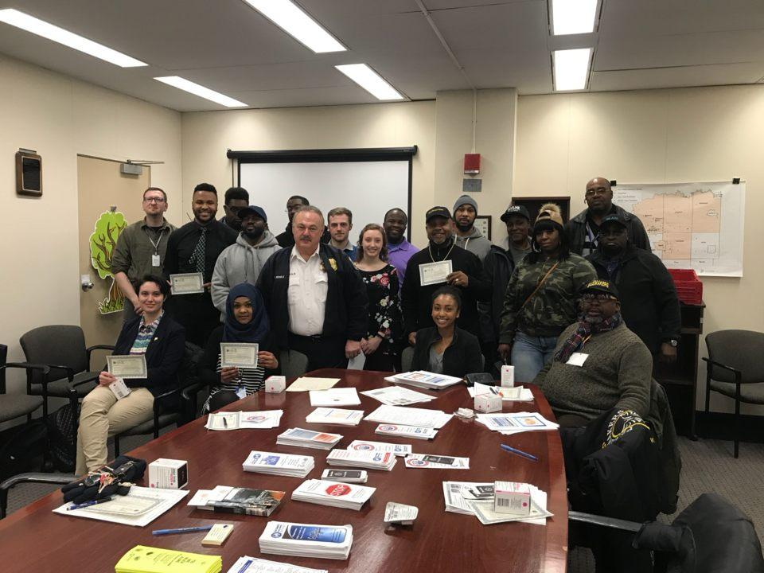

# 4. Beautification and Restoration of Neighborhoods

## The Clean Sweep

Project M.O.V.E. VISTA members work in partnership with the mayors Save Our Street task Force, operation Clean Sweep. The goal of Clean Sweep is to engage residents and help beautify and restore dilapidated neighborhoods. Clean Sweep partners take the time out of a business day to go door to door knocking, inquiring, and addressing the issues the residents face in their neighborhoods. The VISTA members build capacity by evaluating the efficiency of the Clean Sweep partners and work as consultants to make the existing infrastructure more efficient. In addition to that they also serve as liaisons to the City and help build a stronger communal relationship between city resident’s and government officials.

**AmeriCorps VISTA members engaging with residents and helping them recruit volunteers**

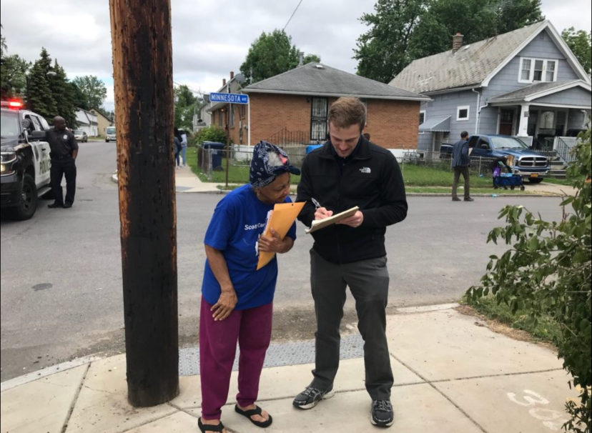

VISTA members engaging with residents about Healthy eating and promoting usage of green space for vegetation growth.

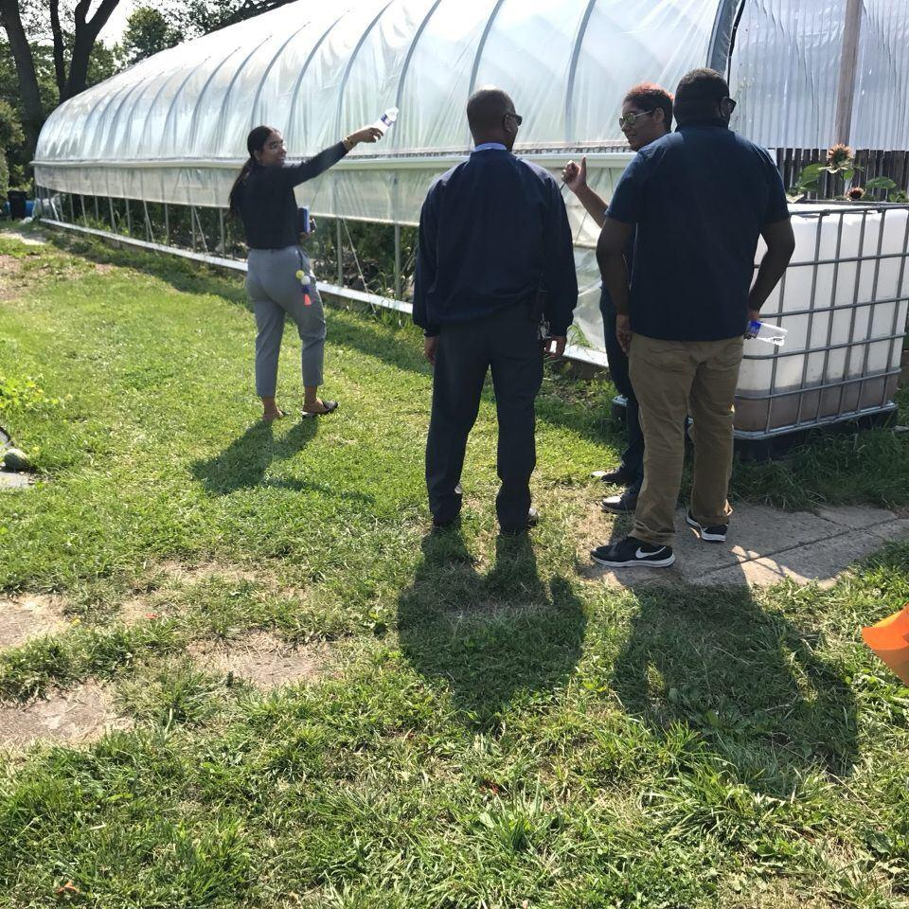

The VISTA members overall role with The Mayor’s Task force has helped the initiative grow and allowed the partners to collaborate better by sharing resources and information. We are also looking to enhance the communal image by encouraging residents to start a block club and use the Mayors Call and Resolution line to tackle blight, hold absentee landlords accountable and address illegal activity in their neighborhoods. Finally, VISTA’s speak with residents to record quality of life issues, bringing them to the proper representatives, and getting them resolved immediately. This strengthens the resident-government bond in the process of restoring the neighborhood. VISTAs develop a model to continue the process after the current work is completed.

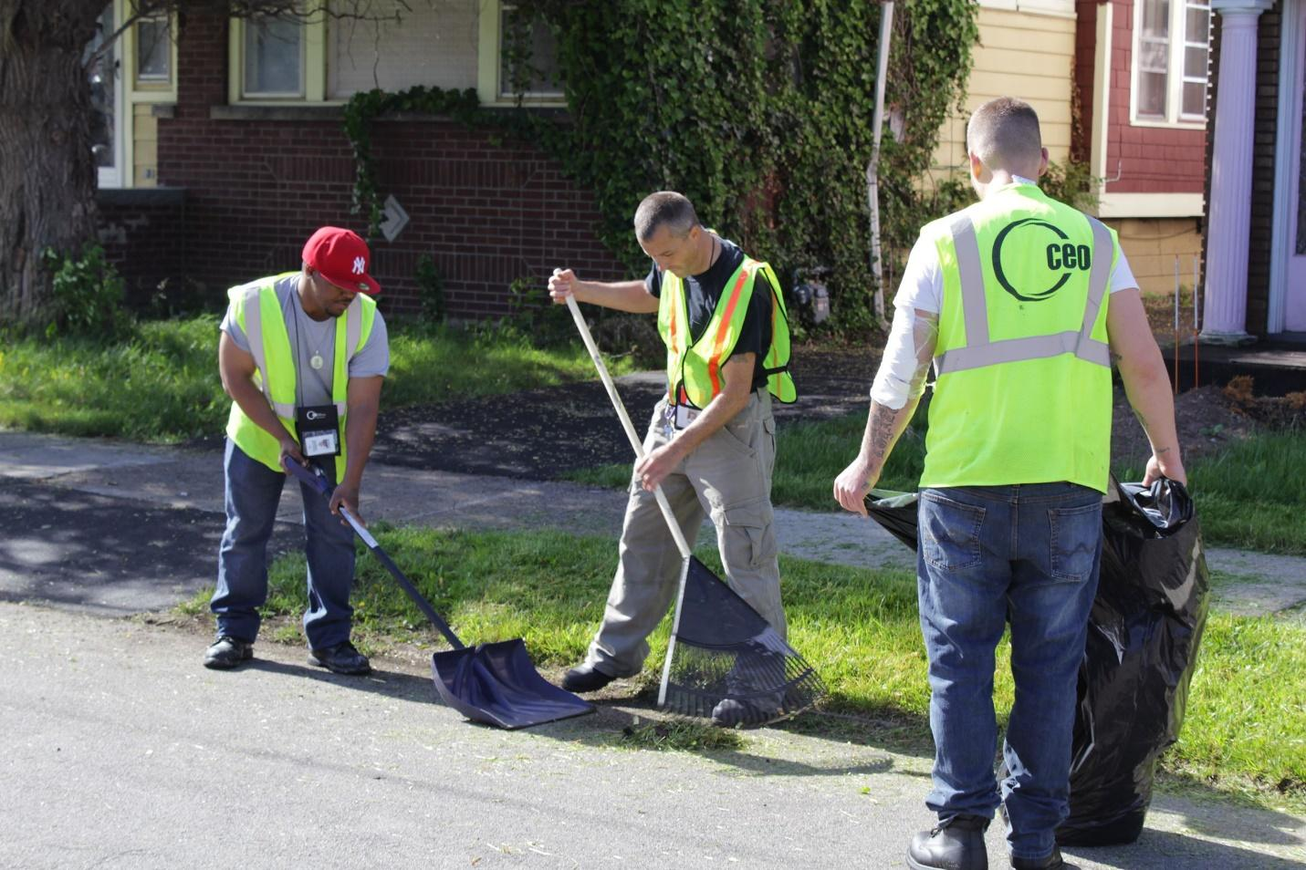

The VISTAs are also responsible for notes taken on quality of life issues revealed by residents. While keeping the teams of partners together in tandem with the second team of partners on the opposite side of the street. There are VISTAs documenting the before and after of the neighborhood when graffiti is removed, trees are trimmed, etc. A VISTA will take notes of inspector actions and analysis. Also there is a VISTA for stakeholder interviews, press requests, and notes to relay to the Mayor at completion.